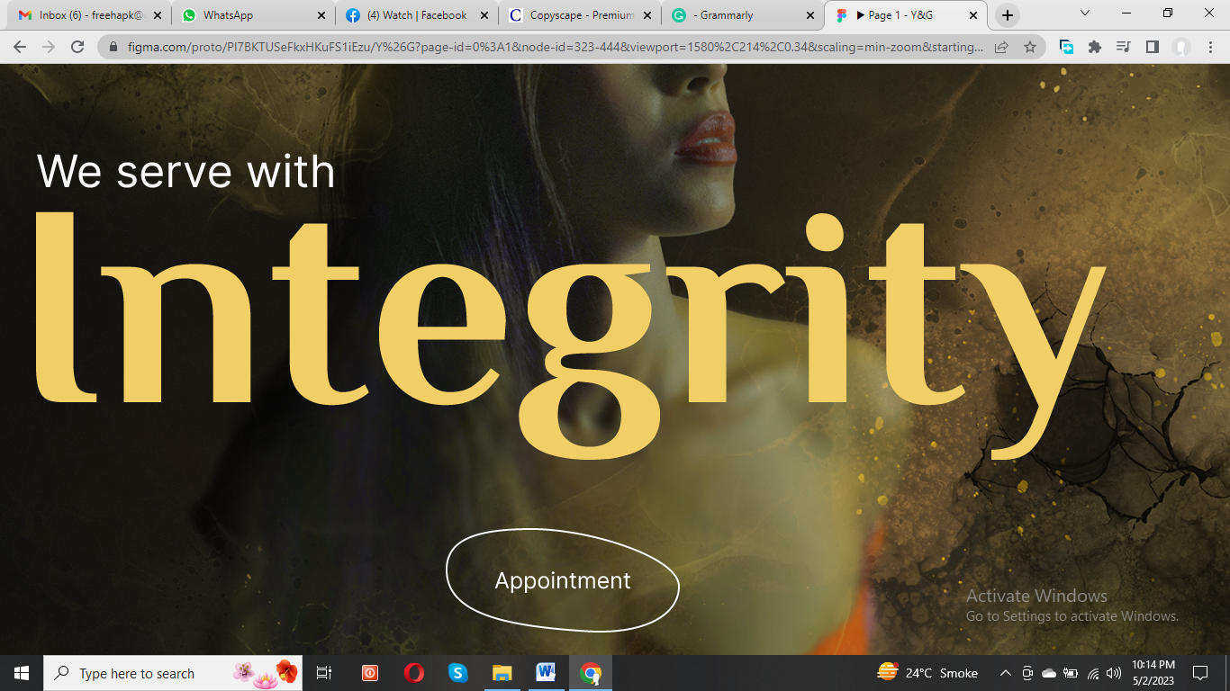

**(Text for banners)**

1. Transform Your Look with Confidence!
2. Y&G Salon

Where Style Meets Perfection

1. Step into Our World of Glamour!

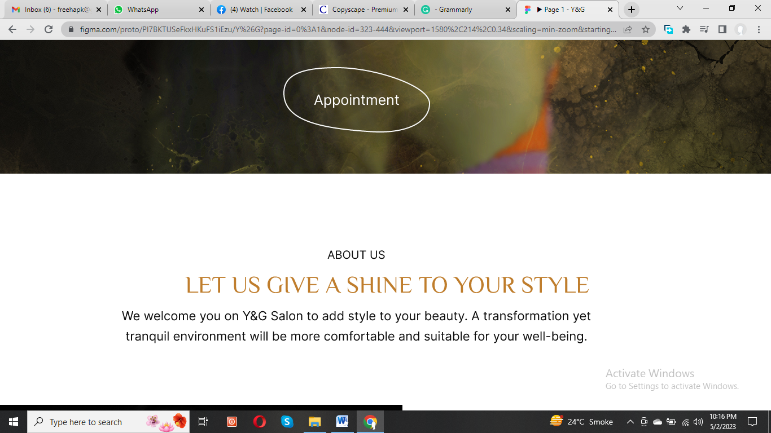

**Let us Help You Flaunt in You Style**

Step into the world of beauty and glamour at Y&G Salon. Our tranquil environment at **beauty salon in Dubai** offers the perfect setting for a transformation that will enhance your natural beauty.

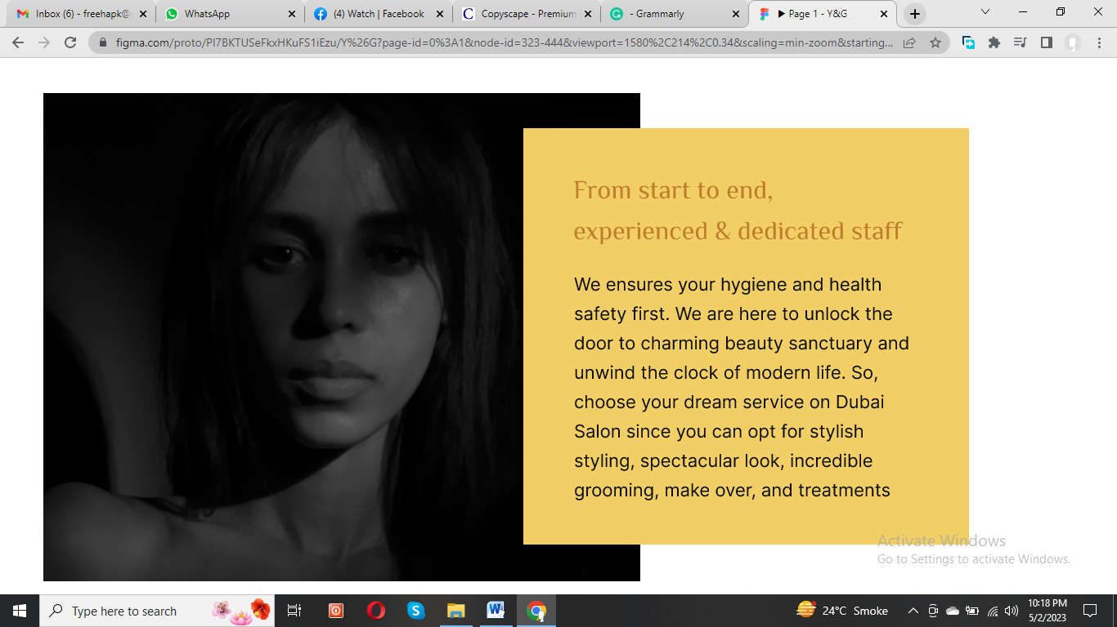

**Experience the Ultimate Transformation at Y&G Salon**

Experienced and dedicated staff will ensure your health and hygiene are top priorities from start to finish. Our **beauty salon Dubai** is a sanctuary where you can escape the stresses of modern life and indulge in your dream services, whether stylish styling, a spectacular new look, incredible grooming, makeovers, or treatments. Trust us to give your style the shine it deserves. We are here for **Home Services Salon Dubai.**

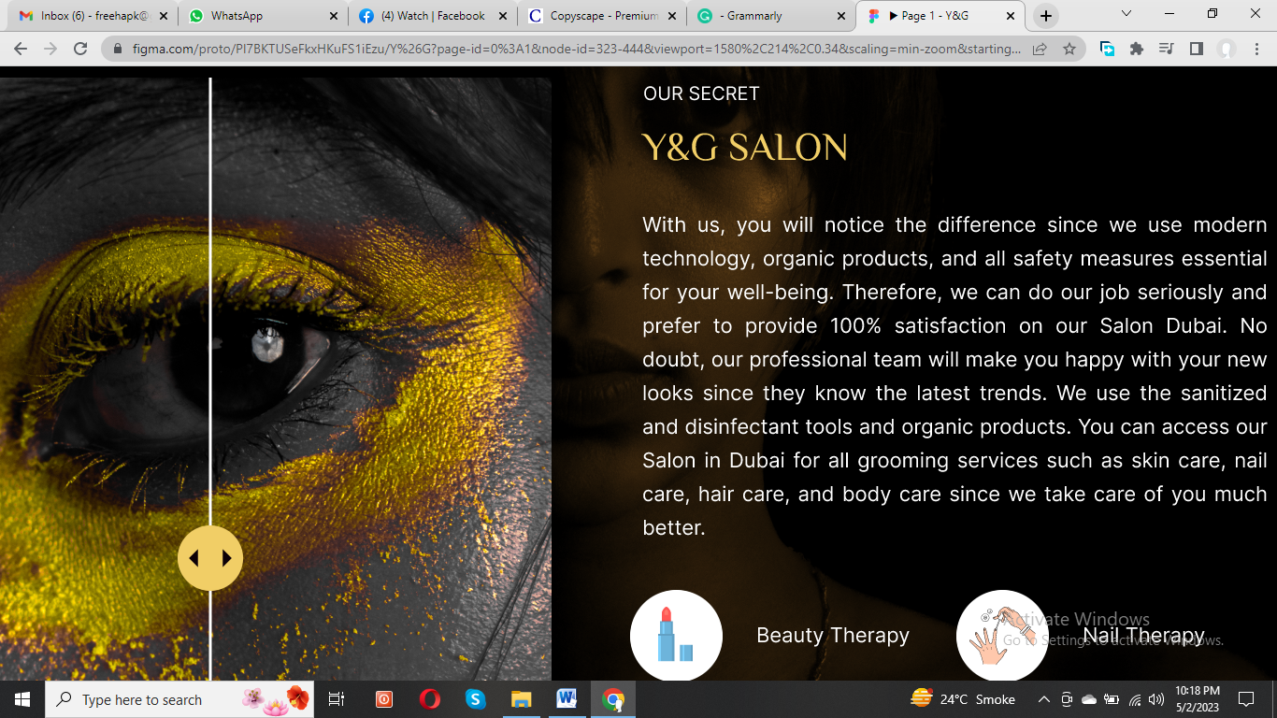

**Y&G Salon**

**Your Glam Hub**

Our **salon in UAE** prioritizes your well-being using modern technology, organic products, and all essential safety measures. Our commitment to providing top-quality service at **beauty salon in Dubai** ensures that we take our job seriously and strive for 100% satisfaction. We with our team stay up-to-date on the latest trends to create stunning looks that will leave you confident and beautiful since we are the **nearest beauty salon to me**. Our secret for **salon at-home services** is that we use sanitized and disinfected tools and organic products to ensure that your experience is enjoyable and safe. From skincare to nail care, hair care to body care, as well as bridal makeup in Dubai, we offer a range of grooming services to meet your needs. Trust us to take care of you and leave you feeling your best. Come visit our **salon in Dubai** today!

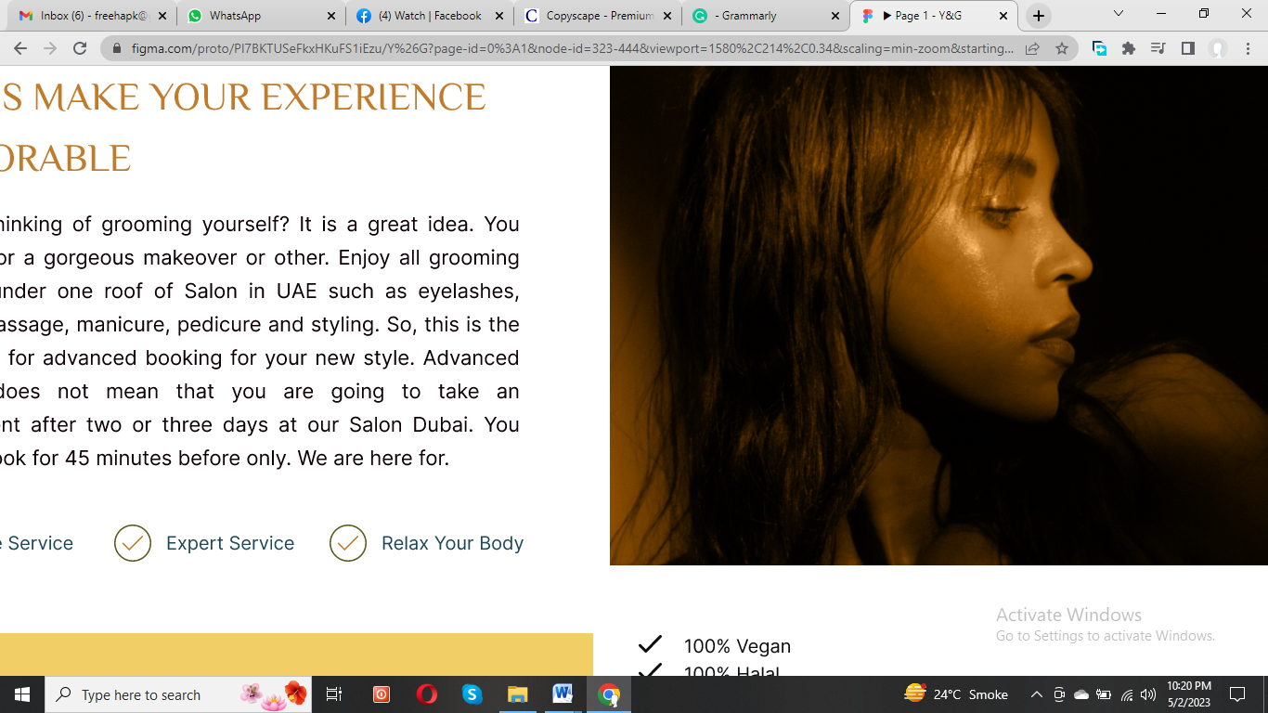

**Relax and unwind while we work our magic!**

Welcome to Our UAE Salon!

Are you looking to treat yourself to some much-needed grooming? Look no further than our **salon in UAE**! We offer a wide range of services under one roof, including eyelash extensions, haircuts, massages, manicures, pedicures, and styling. Don't wait to schedule your appointment for a stunning new look and schedule an appointment for **salon services at home Dubai**. Our advanced booking system allows you to reserve your spot just 45 minutes ahead. No need to wait days or even weeks for the perfect appointment at our **beauty salon Dubai**. Our expert team is here to provide exceptional service and leave you feeling beautiful and confident. Don't hesitate to visit our **salon in Dubai** and discover the ultimate in luxury and pampering. It includes

* **Home Services Salon Dubai**
* Expert Service
* Relax your body
* **Bridal Makeup In Dubai**

Discover Our Natural and Organic Beauty Products here

* Botanical extracts
* Plant-derived glycerin
* Plant-derived essential oils
* Organic olive oil
* Organic sea salt
* HICC-free(Allergen-free) Fragrance
* 100% Halal
* 100% Vegan

**Loyalty Cards & prepaid Membership Cards are available.**

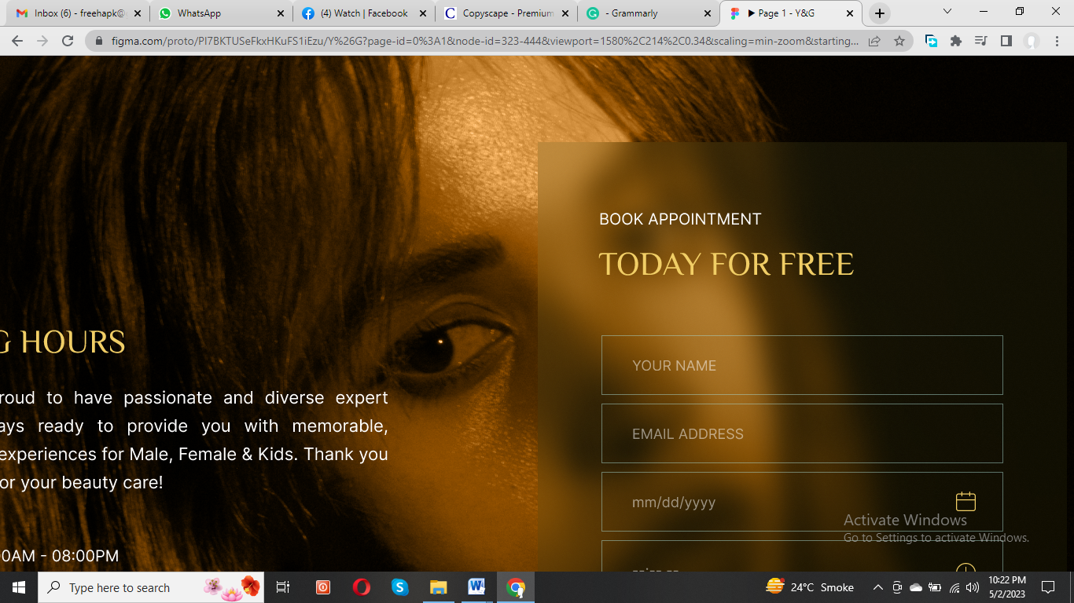

**Y&G SALON FOR MALE & FEMALE**

**Schedule an Appointment**

At Y&G **Salon in UAE**, we understand that our clients lead busy lives. That's why we offer flexible working hours to cater to your needs. Our team of passionate and diverse expert technicians at **beauty salon Dubai** is always ready to provide safe and unique experiences.

Looking for a **nearest beauty salon to me**? We are open Monday to Friday from 8:00 am to 8:00 pm, and on Saturdays and Sundays, we are open from 10:00 am to 10:00 pm. Whether you're looking for a quick beauty fix during your lunch break or a relaxing spa session on the weekend or **salon services at home Dubai**, our **salon in UAE** is the perfect destination.

**Thank you for choosing Y&G Salon for your beauty care needs. We are committed to providing exceptional service and making your experience memorable.**